CHAPTER 3

OPERATING INSTRUCTIONS

CONTENTS

INTRODUCTION 2
PART 1 - OPERATION FROM A BridgeMaster E DISPLAY 2
PART 2 – OPERATION FROM A BridgeMaster II DISPLAY 3
General 3
Initial Settings 3
Operating Instructions 3
Notes 3
PART 3 - OPERATION FROM TRANSCEIVER TEST SET 4
General Description 4
Starting the Programme 4
Initial Settings 5
General Operating Instructions 5
Notes 6

Illustrations

Figure 3.1 - Transceiver Test Set Display 4

CHAPTER 3

INTRODUCTION

The following operating instructions describe control and operation of the Transceiver from various LMS equipments. Control and operation may also be carried out from third party equipments subject to interface agreement.

PART 1 - OPERATION FROM A BridgeMaster E DISPLAY

Note: This is applicable ONLY to transceiver type 65825CA and 65825CD. Transceiver types 65825CB and 65825CC are not compatible with the BridgeMaster E communication protocol.

Operation of the transceiver from the display will be exactly as described in the standard BridgeMaster E Users Guide, Publication number 65800010A.

PART 2 – OPERATION FROM A BridgeMaster II DISPLAY

General

To operate the transceiver from a BridgeMaster II or earlier display, a Display Compatibility Unit type 65840A (or a special variant) must be used to translate the parallel output interface of the Display into the serial communication recognised by the transceiver.

For a 65825CA, or 65825CD transceiver, a standard DCU type 65840A is used.

For a 65825CB or CC transceiver, a modified DCU must be used. Contact LMS for details and quotations.

Initial Settings (applicable when first setting up)

For a 65825CA and 65825CD, set the DIL switch position 5 (green) on the DCU to ON, all other sections to OFF. On the trigger board, set the DIL switch position 5 (green) and positions 7 (violet) and 8 (grey) to ON.

For 65825CB or CC, set the DIL switch on the DCU so that positions 3 (orange), 4 (yellow) and 5 (green) are ON, all other sections to OFF. On the trigger board, set the DIL switch position 5 (green) to ON.

Operating Instructions

Switch the BridgeMaster display ON. The transceiver will auto-start as soon as the power is applied to the DCU. The BridgeMaster display will commence a 3 minute warm-up timer, after which transmit can be selected. During the antenna start-up delay, a LOW VIDEO alarm will be generated, which should clear after acknowledgement.

From this point onwards, all operation of the transceiver via the DCU will appear to be almost identical to a BridgeMaster II top unit, the only differences being in the BIST data, where some values are not updated directly from the transceiver.

For Operational Information, refer to BridgeMaster II Users Guide, Publication Number 65600009.

Notes

Check that LED 1 on the DCU is pulsing on and off, and LEDs 3 & 4 are off. [This indicates that power is on the DCU, the software is running, communications have been established in both directions, and there are no data errors in the return path.

PART 3 - OPERATION FROM TRANSCEIVER TEST SET

General Description

The Test Set referred within this section is a compact PC-based programme running under Windows 95, and is designed to emulate the Display Control Functions as far as generation of all formats of control messages, and display the relevant tellbacks received. It cannot verify or respond to the Display Triggers or Video signals but can control all other functions of the transceiver.

It is formulated to give a user-friendly graphic screen which is readily interpreted and, like other windows programmes, depresses non-selectable options into a grey scale, whilst enhancing options and active tellbacks in bold format.

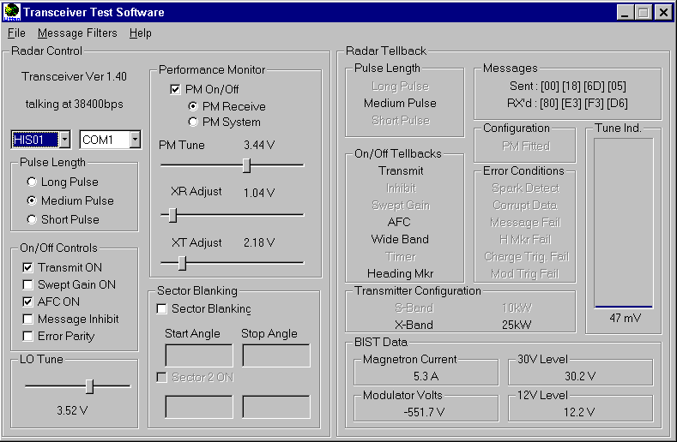
Figure 3.1 - Transceiver Test Set Display

It is assumed that the operator is familiar with the usage of Windows based programmes.

Starting the Programme

From the Windows Icon page, select the “TxRx Test” Icon. using the left button of the mouse.

Initial Settings

For a 65825CA and a 65825CD, select communication protocol NIS02. The tellback message should display “talking at 38400 baud”. On the trigger board, set the DIL switch as follows: -

1 | 2 | 3 | 4 | 5 | 6 | 7 | 8
brown | red | orange | yellow | green | blue | violet | grey
OFF | OFF | OFF | OFF | ON | n/a | ON | OFF

For 65825CB or CC, select protocol NIS01, the tellback should display “talking at 9600 baud”. On the trigger board, set the DIL switch as follows:-

1 | 2 | 3 | 4 | 5 | 6 | 7 | 8
brown | red | orange | yellow | green | blue | Violet | grey
OFF | OFF | OFF | OFF | ON | n/a | OFF | OFF

Select the output port (COM1, 2, 3 or4) to suit computer on which software is installed

To operate using internally generated azimuth and heading marker pulses, set LK5 and LK6 to position 1-2. Otherwise set both to position 2-3.

To operate from the test socket (TSB on Input Board), set S1 on Input Board:-

1 | 2 | 3 | 4 | 5 | 6 | 7 | 8
brown | red | orange | yellow | green | blue | Violet | grey
ON | ON | ON | ON | OFF | OFF | OFF | OFF
Otherwise leave set to inverse of above, 1 to 4 OFF and 5 to 8 ON.

General Operating Instructions

The display screen is split vertically. The left-hand side is the Radar Control, whilst the right hand side is the Radar Tellbacks. All setting information is therefore effected upon the control screen. This is done in four possible ways.

1. Selection of a pulse length is achieved by selecting in the round window for the desired pulse-length, and the new one will replace the currently selected mode, since the three are mutually exclusive.

2. Selection and cancellation of other parameters is done by clicking on the appropriate check box, and a tick will appear against the active functions

3. The third type of entry is sectoring data, which is done from the keyboard. [Note this is only applicable to 65825CB and CC]. First click in the start window and enter a number from the keyboard. Press tab to step to the next window and add an end angle. Then the select window above the sector is activated.

4. The last type is changing the analogue inputs; this is achieved using the slider bar. The operator can either drag the slider pointer, or click on either end to step. The output value is written underneath the slide bar to give resolution.

In the top right-hand corner of the screen is displayed the four-byte message being sent to the transceiver. When a parameter change request is sent, the message to effect that request is shown momentarily. Then the routine status update message is displayed, being the repeated message sent to the transceiver to keep it alive.

Beneath this is shown the reply messages from the transceiver, and these are sequential, scrolling through all of the parameters. The data extracted from the transceiver is all displayed on the remainder of the right hand screen, either as highlighted status words; or in the case of BIST values as a number; and finally the tune indicator is shown as a vertical bar graph. Using the message filters pull-down menu, the scrolling messages can be individually captured.

The only reply parameter from the transceiver which is shown on the left hand side of the display is the transceiver software version number, and this appears in the top left corner, above the baud rate.

Notes

1. Failure to establish communication is indicated by the message in the top left hand corner stating “No Transceiver”.

2. Remember that attempting to select transmit mode whilst the timer tellback is highlighted will fail!

3. If Transmit is selected, but the inhibit tellback is also highlighted, this indicates that the remote silence line into the transceiver is over-riding the command.

4. When transmit is selected, the system waits for one complete revolution of the antenna (indicated by two successive heading markers) before accepting the instruction. If no heading marker input is being provided to the transceiver, transmission will NOT start unless the heading-marker over-ride switch has been activated on the Trigger Board (DIL Switch S1 position 2(red) set to ON)

5. If the internally generated azimuth pulses and heading marker pulse are being used on the trigger board (LK5 & LK6), these will NOT be reproduced at the input board buffered outputs (TSC & TSE)

Inter Unit Wiring Details:

Computer Output | TxRx |  | Computer Input | TxRx
∗RS422+ | TSB1 |  | RS422+ | TSB4
∗RS422- | TSB2 |  | RS422- | TSB5

∗Note: RS422+ is the normally positive output.

