CHAPTER 3

ADDENDA FOR NON-STANDARD UNITS

CONTENTS

GENERAL INTRODUCTION 2
SECTION 1: TRANSCEIVER COMPATIBILITY UNIT 65841F 3
SECTION 2: INTERSWITCH UNIT 65842F 14
SECTION 3: SCANNER CONTROL UNIT 65427AH 26

GENERAL INTRODUCTION

A number of units used in the system are special variants of standard units. This section of the manual explains the differences and lists any non standard spares

SECTION 1: TRANSCEIVER COMPATIBILITY UNIT 65841F

Contents

GENERAL DESCRIPTION. 4
INSTALLATION AND COMMISSIONING 5
TECHNICAL SPECIFICATION 10
ENVIRONMENTAL SPECIFICATION 13
SPARES LIST 13

Illustrations

FIGURE 3.1 TCU Mains Input Connections to TSP 6
FIGURE 3.2 Transceiver Compatibility Unit PSU PCB 65841803 7
FIGURE 3.3 Transceiver Compatibility Unit Logic PCB 65841802 8
FIGURE 3.4 Transceiver Compatibility Unit Installation Details 9

GENERAL DESCRIPTION.

The Transceiver Compatibility Unit processes the SCOUT azimuth, heading marker, sync, video and error signals into a form compatible with BridgeMaster E.

The Transceiver Compatibility unit is a bulkhead-mounted unit that comprises a Power Supply PCB with filtered mains input and a Logic PCB.

All input connections, with the exception of the mains, are made to the logic PCB.

While mains is present at the power supply, it is in a standby condition, on detecting the serial control message from BridgeMaster E it switches to its operating state. It is the presence of volts on the serial control message input that starts the power supply, not the message content.

The azimuth, heading marker and error signal from SCOUT are converted into a serial message to be transmitted to the BridgeMaster E system in RS422 format.

The azimuth and heading marker are also buffered and converted to RS422 format for use by the BridgeMaster E Transceiver.

The sync from the SCOUT Processor is converted from single ended coaxial form into RS422.

The video is buffered and provision is made to adjust the video amplitude to normalise the video between the SCOUT and BridgeMaster-E Transceivers.

The serial control message from BridgeMaster-E is buffered and re-transmitted to the SCOUT transceiver.

A video inverter is included to invert the negative video from the Interswitch into the positive signal required by the Video Control Unit and the BTS NAVRAD.

There are no operator controls associated with the unit but a commissioning procedure is carried out on installation to set up internal links.

INSTALLATION AND COMMISSIONING

Link Settings

The link settings on the Power Supply PCB are intended for testing and fault-finding purposes and are factory set for normal operation. They should only be moved/removed by a qualified Service Engineer.

The Logic PCB has two links that must be set on installation, LK1 and LK2, which define the output impedance of the video buffers. LK3 is a test link and is not fitted.

Power Supply PCB

LKA - Start Test Link
Normal Operation Fit 2 to 3
Test Operation Fit 1 to 2

LK1 - High Voltage Isolation Link (not used in this system)
Normal Operation Fitted
Test Operation Not Fitted

LK2 & LK3 - Input Voltage Select Links
230V LK2 Fitted
115V LK3 Fitted

LK4L & H, LK5L & H - Motor Supply Select Links (not used in this system)
Low Speed X-Band LK4L & LK5L Fitted
High Speed X-Band LK4H & LK5H Fitted

TCU Logic PCB

LK1 Aux Video OUT Impedance
50 Output Fit 1 to 2
75 Output Fit 2 to 3

LK2 SCOUT Video OUT Impedance
50 Output Fit 1 to 2
75 Output Fit 2 to 3

LK3 - ATE Test Link
Factory Setting Not Fitted

LK4 Bypass Video Buffer
Normal Fit 1 to 2
Bypass Fit 2 to 3

LK5 Bypass Video Buffer
Normal Fit 1 to 2
Bypass Fit 2 to 3

FIGURE 3.1 TCU Mains Input Connections to TSP

FIGURE 3.2 Transceiver Compatibility Unit PSU PCB 65841803

FIGURE 3.3 Transceiver Compatibility Unit Logic PCB 65841802
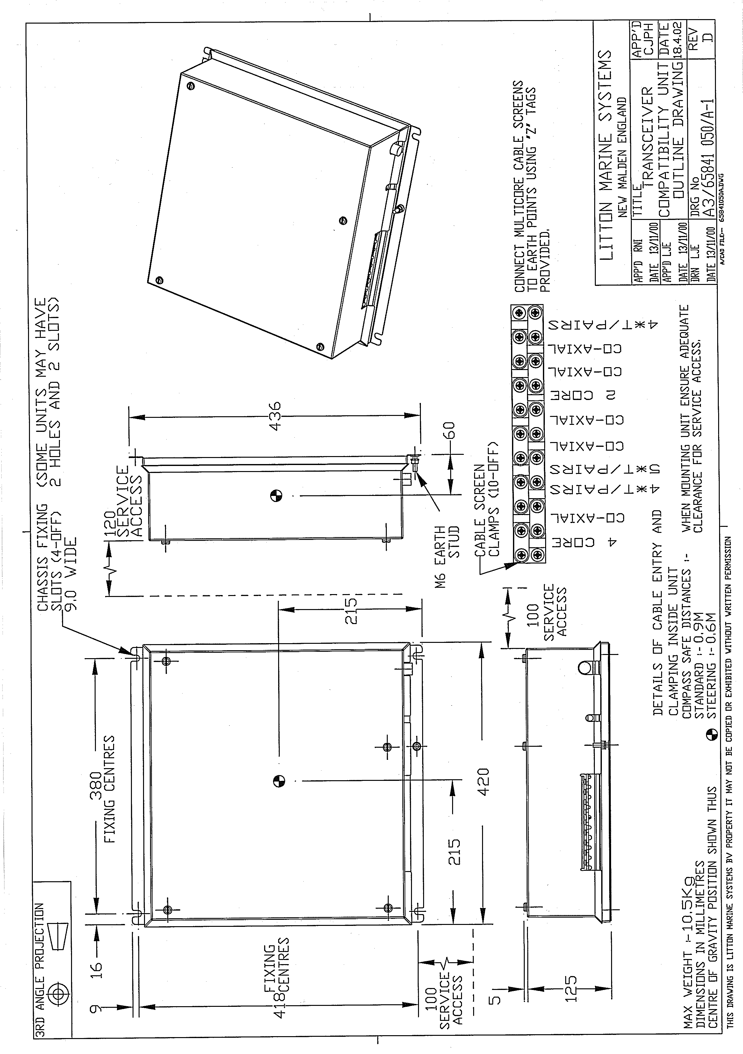

FIGURE 3.4 Transceiver Compatibility Unit Installation Details

TECHNICAL SPECIFICATION

Inputs to Logic PCB
SCOUT Video Input
Amplitude 2.5V min to 4.5V max
Polarity Negative
Impedance 75
Connection Type BNC

SCOUT Sync Input
Amplitude 13.5V min to 16.5V max
Polarity Positive
Duration 1μs ±10%
PRF 1000Hz
Impedance 75
Timing 0 to -100ns w.r.t. T₀
Connection Type BNC

Auxiliary Video Input
Amplitude 2.5V min to 4.5V max
Polarity Negative
Impedance 75
Connection Type BNC

SCOUT Azimuth Input
Amplitude RS422
Pulses per Revolution 4096
Input Impedance 100 AC coupled
Connector Type Terminal block

SCOUT Heading Marker Input
Amplitude RS422
Pulse Width 1.2ms at 24 RPM
Input Impedance 100 AC coupled
Active State Space (binary 0)
Triggering Leading edge (negative going)
Connector Type Terminal block

SCOUT Error Signal
Amplitude +5V ±10%
Sense+5V denotes error
Floating denotes no error
Input Impedance 1k for input voltages < 5V
Connector Type Terminal block

Outputs from Logic PCB
Radar Video Output
Amplitude (adjustable) <2.5v to >4.5V
Polarity Negative
Impedance 75
50 selectable
Connector Type BNC

Radar Trigger
Amplitude RS422
Timing As SCOUT trigger input
Duration As SCOUT trigger input
Connector Type BNC

Auxiliary Video Output
Amplitude (adjustable) <2.5v to >4.5V
Polarity Positive
Impedance 75
50 selectable
Connector Type BNC

RS422 Buffered SCOUT Azimuth Data.
Azimuth Out
Amplitude RS422
Pulse per Revolution 4096
Connector Type Terminal block

Heading Marker
Amplitude RS422
Pulse Width 1.2ms at 24 RPM
Active State Space (binary 0)
Triggering Leading edge (negative going)
Connector Type Terminal block

Data to Display (TX DATA)
Amplitude RS422
Baud Rate 76.8 kB
Connector Type Terminal block

Control Data from Display (DUDATA)
Amplitude RS422
Baud Rate 76.8kB
Connector Type Terminal block

Control Data to SCOUT
Amplitude RS422
Baud Rate 76.8kB
Connector Type Terminal block

Power Supplies.

Inputs:

Single Phase AC input
230V (selectable by link) 230V ± 10% (factory setting)
115V (selectable by link) 115V ±10%
Frequency 47Hz min 64Hz max

Over-voltage Transients 40% above nominal for 1 sec max without causing damage.
At or above this level, the input fuse may blow.

Pulsed transients + 1200V peak, rise time 2 to 10us, duration <20us. Common or differential mode.

Under-Voltage Mains dropout is monitored and may cause the system to reset.

Outputs:

The output supplies are listed for information only.

Modulator HT.Voltage 140V ± 10%.
Current 10kW 600mA max.
25kW 800mA max.

+15V for Bite & Bearing +15V ± 6% at 400mA max

+15V +15V ± 10% at 1.5A max

-15V -15V ± 10% at 100mA max

+24V +24V ± 20% at 2A mean (4.6A peak)

Internal Circuit Power Supplies.

+15V +15V ± 5%. at 100mA max

+5V +5V ± 5% at 250mA max

-15V -15V ± 5%. at 50mA max

+36V +36V ± 5% at 50mA max

ENVIRONMENTAL SPECIFICATION

Temperature
Operating -15°C to +55°C
Storage -25°C to +70°C

Relative Humidity
95% at 40°C ( non condensing)

Compass Safe Distances
Standard | Steering
0.9m | 0.6m

SPARES LIST

Description | Part Number
Power Supply PCB | 65841803
Logic PCB | 65841802
Mains Filter | 1586513
Fuse 3.1A | MA00007245

SECTION 2: INTERSWITCH UNIT 65842F

Contents

GENERAL INTRODUCTION 15
INSTALLATION AND COMMISSIONING 17
INTERFACE SPECIFICATIONS 20
SYSTEM STATUS 21
INTERCONNECTIONS 21
TECHNICAL SPECIFICATION 24
ENVIRONMENTAL SPECIFICATION 24
SPARES LIST 25

Illustrations

FIGURE 3.5 Interswitched System 16
FIGURE 3.6 Interswitch Unit Installation Details 18
FIGURE 3.7 Interswitch Logic Pcb 19
FIGURE 3.8 Typical Example of Status Panel Readout 21
FIGURE 3.9 Block Diagram – Interswitched System 23

GENERAL INTRODUCTION
The Interswitch unit performs the necessary selection of data from either the SCOUT transceiver or the BridgeMaster E transceiver and distributes it to the two BridgeMaster E ARPA displays and via the Display Compatibility unit and the Video Control unit to the BTS NAVRAD. See FIGURE 3.5
The Interswitch similarly selects control data from one of the ARPA displays and routes it to the transceivers.

The Interswitch in combination with the control software in the ARPA displays ensures that only one of the ARPA displays is selected to control the active transceiver, and that the data from that transceiver is distributed to all three displays.
The display that is selected to be in control is defined as the Master; the others are defined as Slaves.
Either BridgeMaster E display can be selected to be Master.
There must always be one display selected as Master.

The Interswitch unit is bulkhead mounted, and comprises a purpose designed enclosure and one logic PCB.

Power to the unit is supplied from the two ARPA displays controlling it.
Therefore if either display is turned on power is present at the Interswitch unit.

All connections to the unit are made on the logic PCB.
The braids of interconnecting cables are clamped at the entry to the unit as part of the EMC screening.

Bypass connectors are provided to enable the Interswitch control logic to be manually bypassed in the event of a failure.

The operator has the following configuration options.

Current Configuration | Alternative Available Configuration
Master of SCOUT | Master of BridgeMaster E
Master of BridgeMaster E | Master of SCOUT
Slave to BridgeMaster E | Master of BridgeMaster E
Slave to SCOUT | Master of SCOUT

SCOUT
Transceiver
(TXA)

BridgeMaster E
Transceiver
(TXB)
Interswitch
CIC Display
DUB
Video Control Unit

FIGURE 3.5 Interswitched System

INSTALLATION AND COMMISSIONING

DIL SWITCHES
Two groups of DIL switches are used to indicate which Displays and Transceivers are connected to the Interswitch.
To indicate that a Display or Transceiver is connected to the Interswitch, set the appropriate switches to the off position.

SW1 selects Display units SW2 selects transceivers.

Switch1
Position | Setting | Function
1 | Off | DUA fitted
2 | Off | DUB fitted
3 | Off | DUC fitted
4 | On | DUD not fitted

Switch 2
Position | Setting | Function
1 | Off | TXA fitted (SCOUT)
2 | Off | TXB fitted (NAV)
3 | On | Not used
4 | On | Not used

Link Settings

LK1 Interswitch mode
LK1 Set 1 to 2 Local Mode.
LKI Set 2 to 3 Global Mode
Link1 selects LOCAL only LOCAL mode is used for this system. This link is not active for this system.

LK2 Reset Defaults
LK2 Set 1 to 2 Normal.
LK2 Set 2 – 3 Reset defaults
This would normally reset default configuration at power up. This link is not active for this system as the system automatically resets defaults at power up.

The system defaults to DUA (Bridge Display) master of TXA (SCOUT)

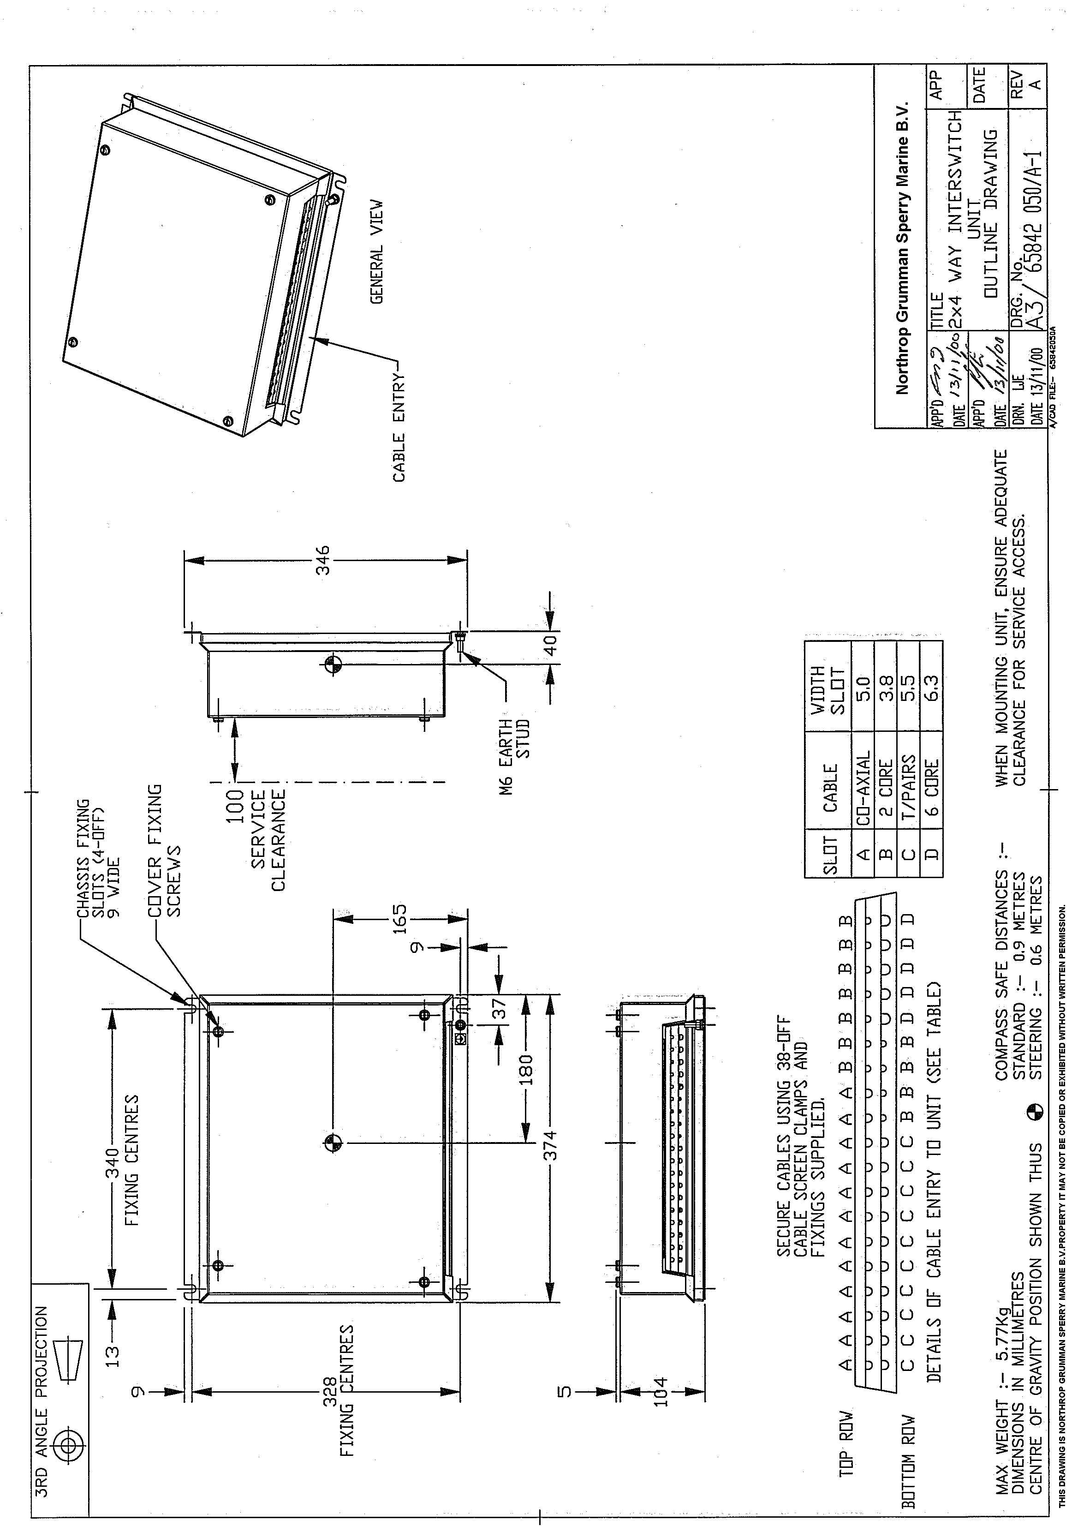

FIGURE 3.6 Interswitch Unit Installation Details

FIGURE 3.7 Interswitch Logic PCB

INTERFACE SPECIFICATIONS
Interface to Transceiver
There is a bi-directional serial port to send control signals to and to receive signals from the transceiver. This is an RS422 differential signal.
Trigger is an RS422 signal on a separate twisted pair,
Video is sent down a separate coaxial cable. The video is received via a coaxial cable.

Radar Video Input
Peak amplitude -2.5V to -5.5V
Shoulder noise -0.25V minimum
Input Impedance 75

Interface to Display Unit (Transceiver Information)
There is a bi-directional serial port to send signals to, and to receive signals from the display or compatibility unit. These are RS422 differential signals. Trigger is an RS422 signal on a separate twisted pair.
Video is sent down a separate coaxial cable.

Radar Video Output
Peak amplitude -2.5V to -5.5V
Shoulder noise -0.25V minimum
Input Impedance 75

Control
There is a bi-directional serial port to send and receive signals from the display. These are RS422 differential signals. One receives the configuration requests from the Display, the second one returns acknowledge and configuration signals back to the Display.
Additional cables bring in power from the displays to power the unit.

Bypass Connections
On the Interswitch PCB, additional connectors are provided. These allow a display to be connected to a Transceiver, bypassing the Interswitch. In the standard Interswitch, this permits TXA to be connected to one Display and TXB to be connected to another of the four possible Displays. Two displays will therefore be out of action.
Note:
In this system the SCOUT Transceiver must be connected by the bypass connectors to the Display. The system requires the azimuth data from the SCOUT Scanner unit to work.
The connector for the BridgeMaster Transceiver should be disconnected.
The operator must select the mode of operation dependent on the transceiver connected.
i.e. Master of NAV if the BridgeMaster E transceiver is connected,
or Master of SCOUT if the SCOUT transceiver is connected.

Note: MIST will not be available to any Display in Bypass Mode.

General Distribution Connectors (not used in this system)
These enable LOG, COMPASS, NAV I/P etc to be distributed to all the display

units via parallel connected terminal blocks. It comprises:

1 input terminal block and 4 output terminal blocks on the Interswitch PCB.

SYSTEM STATUS

Visual indication of the system status is provided.
Green and Red LEDs show whether a display is connected to Transceiver A or
Transceiver B.
Additional Green and Red LEDs show whether the Display Unit is master or slave to the Transceiver. If a Display has not been configured, then the associated LED will not be illuminated.

FIGURE 3.8 Typical Example of Status Panel Readout

Mutual Interference Suppression Trigger (MIST is not used in this system)
There is one input from an external source that is mixed with the triggers from each Transceiver. The combined signal is fed out as an external display MIST. Each Display is supplied with this composite trigger excluding the trigger from the Transceiver that the Display is currently connected to. The MIST trigger blanks the display video for about 12μs following a trigger from a transceiver that is not selected by the display. This reduces interference from an adjacent radar on own ship.

INTERCONNECTIONS
All inputs and outputs enter and leave on the underside of the Interswitch Unit. All connections physically plug directly into the Interswitch logic PCB.

The cables to the Turning Units/Transceivers consist of a quad twisted pair cables with overall screen for Trigger, and the bi-directional serial data, and a separate coaxial cable for the Video.

The cables to the Display Units consist of two quad twisted pair cables. One provides the Transceiver signals for Trigger, and bi-directional serial data, the other the bi-directional Interswitch control data, positive and negative power. The Transceiver video input and output are via co-ax cables, as is the output MIST.

The Interswitch Unit has one External Transceiver MIST co-ax input, one External Display MIST co-ax output and four co-ax Display MIST outputs.

FIGURE 3.9 Block Diagram – Interswitched System

TECHNICAL SPECIFICATION

Interswitch Power Supply

Each Display Unit supplies +12V and -12V to the Interswitch.
The +12V) inputs are diode OR'd to produce +11V
The -12V) inputs are diode OR'd to produce -11V
An on-board regulator produces +5V for the logic.

Interswitch Unit Hardware Description

A 89C52 microcontroller with on-board Flash memory running at 12 MHZ communicates with the Display Units via bi-directional serial links. The data transferred includes status i.e. Display is master or slave, which Transceiver is connected to which Display. A watchdog facility is also provided.

A Quad UART is used for the bi-directional serial communication with the Display Units or Compatibility Unit. Received data generates interrupts for the microcontroller which reads the data from the UART and acts upon that data. A message is then returned with the new status. Any change of status is stored in an EEPROM allowing the Interswitch to return to the current status in the event of a power failure.

Logic multiplexers are used to route the signals between the Display Units and Transceivers and analogue 'T' switches route the video.

The microcontroller also drives an LED status display.

ENVIRONMENTAL SPECIFICATION

Temperature
Operating -15°C to +55°C
Storage -25°C to +70°C

Relative Humidity
95% at 40°C ( non-condensing )

Weights and Dimensions
 | Height (mm) | Depth (mm) | Width (mm) | Nominal Weight (kg)
2-Way Interswitch Unit 65842F | 346 | 109 | 374 | 5.0

Compass Safe Distances
 | Standard | Steering
2-Way Interswitch Unit 65842F | 0.9 m | 0.6 m

SPARES LIST
Description | Part Number
Logic PCB | 65842801

SECTION 3: SCANNER CONTROL UNIT 65427AH

Contents

INTRODUCTION 27
COMMISSIONING 27
SPARES 28

Illustrations

FIGURE 3.10 Scanner Control Unit 65427AH 27
FIGURE 3.11 Internal Connections Scanner Control Unit 65427AH 28

INTRODUCTION
Scanner Control unit 65427AH is identical to Scanner Control unit 65837AH apart from the operating voltage of the contactor. This is 24V dc instead of 12V dc.
For installation and servicing details use Ancillaries Units Manual 6500012 Chapter 6.

COMMISSIONING
Linking.
Link Contactor 1 (L1) to Thermal Overload terminal 4 see Figure 3.15

Current Trip Setting.
Set current trip to minimum. i.e. fully anti-clockwise.

FIGURE 3.10 Scanner Control Unit 65427AH

FIGURE 3.11 Internal Connections Scanner Control Unit 65427AH

SPARES

This is a replaceable unit so there is no separate spares listing

