**2003 ELECTRICAL**

**Fuses & Circuit Breakers - New Beetle & New Beetle Convertible**   
**IDENTIFICATION**

**ENGINE CODE**

Engines are identified by a 3-letter code stamped on the engine. For engine code locations, see **Fig. 1** -**Fig. 3** . Engine codes are also located on the vehicle data plate.

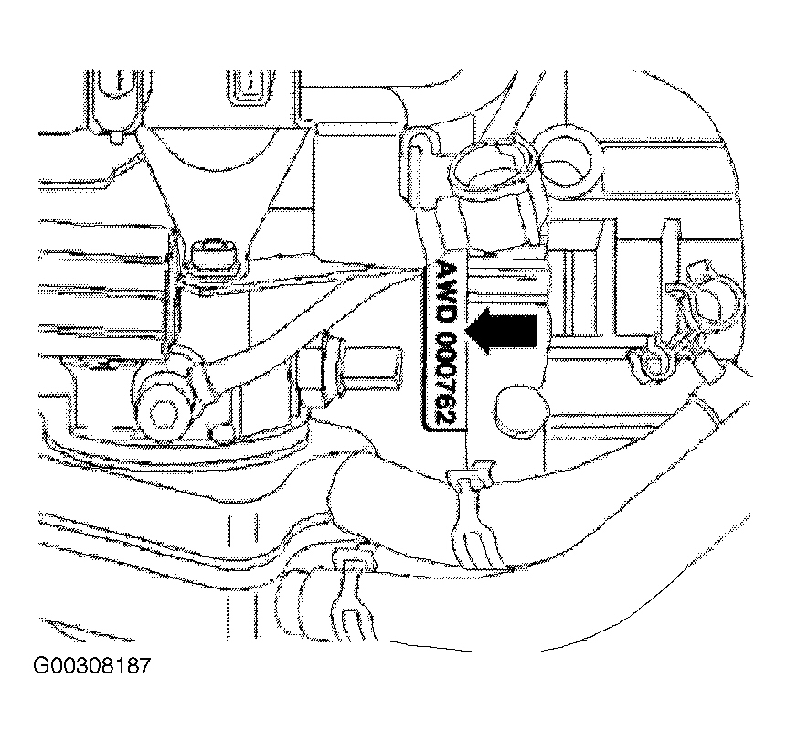

**NOTE: Engine number for 1.8L turbo can be found on mating flange between engine**   
**and transmission. Additionally there is a sticker on cylinder head (valve) cover**

**with engine code and serial number.**





**Fig. 1: Locating Engine Identification Code (1.8L -AWD Shown; AWV Similar)**

**Courtesy of VOLKSWAGEN UNITED STATES, INC.**

**NOTE: Engine code for 1.9L TDI is located between diesel injection pump and exhaust**   
**manifold, on engine block. Additionally there is a sticker on the timing belt**   
**guard containing engine code and serial number. Engine code is also included**   
**on vehicle data plate.**

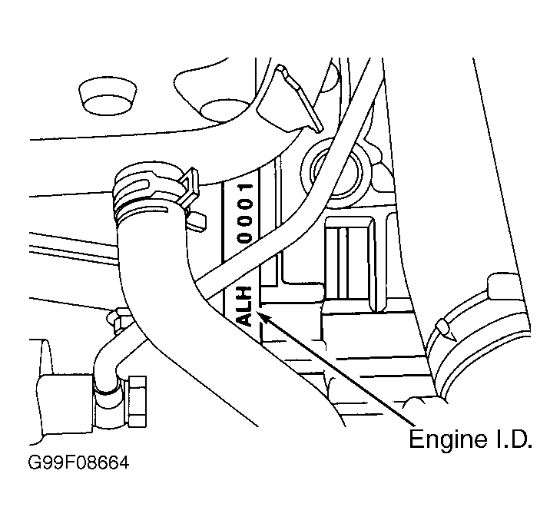

**Fig. 2: Locating Engine Identification Code (1.9L TDI - ALH)** **Courtesy of VOLKSWAGEN UNITED STATES, INC.**

**NOTE: Engine code and serial number for 2.0L is located can be found on flange**   
**between engine/transmission. Additionally there is a sticker on the timing belt**

**guard containing engine code and serial number. Engine code is also included**   
**on vehicle data plate.**

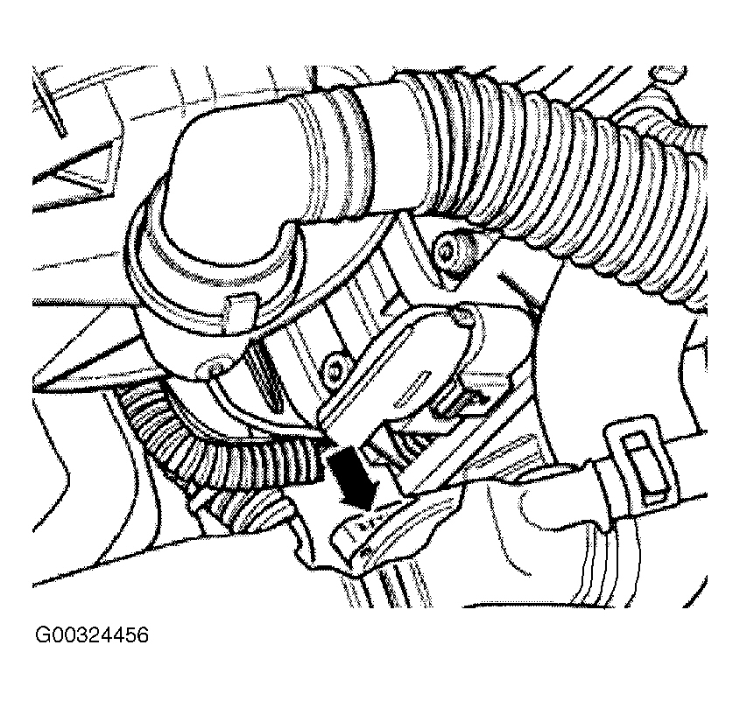

**Fig. 3: Locating Engine Identification Code (2.0L - AVH/AZG & BDC)**   
**Courtesy of VOLKSWAGEN UNITED STATES, INC.**

**FUSES**

**FUSE COLOR IDENTIFICATION**

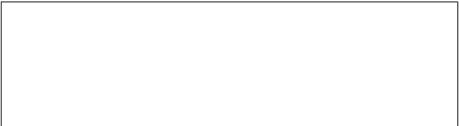**FUSE COLOR/AMP RATING**



|  |  |
| --- | --- |
| **Fuse Color** | **Amp Rating** |
| Beige | 5 |
| Blue | 15 |
| Brown | 7.5 |
| Green | 30 |
| Red | 10 |
| Violet | 3 |





|  |  |
| --- | --- |
| White | 25 |
| Yellow | 20 |

**FUSE (HOLDER) PANEL LOCATION**

Fuse (holder) panel is located behind trim panel on far left side of dashboard. See **Fig. 4** .

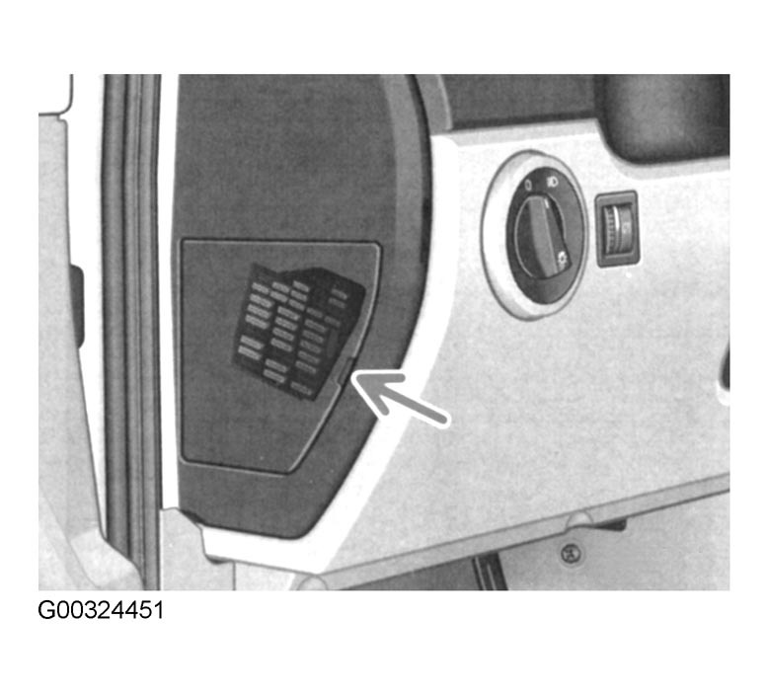



**Fig. 4: Locating Fuse (Holder) Panel**

**Courtesy of VOLKSWAGEN UNITED STATES, INC.**

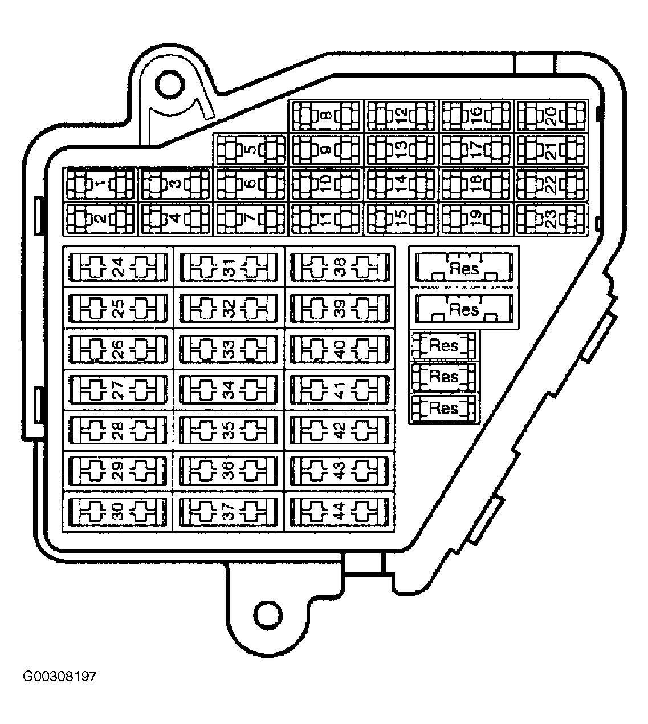

**Fig. 5: Identifying Fuse Panel Fuse Locations**   
**Courtesy of AUDI OF AMERICA, INC.**

**FUSE PANEL IDENTIFICATION**

**Fuse Bracket/Battery Panel**

Fuse bracket/battery panel is located on battery cover. See **Fig. 6**.

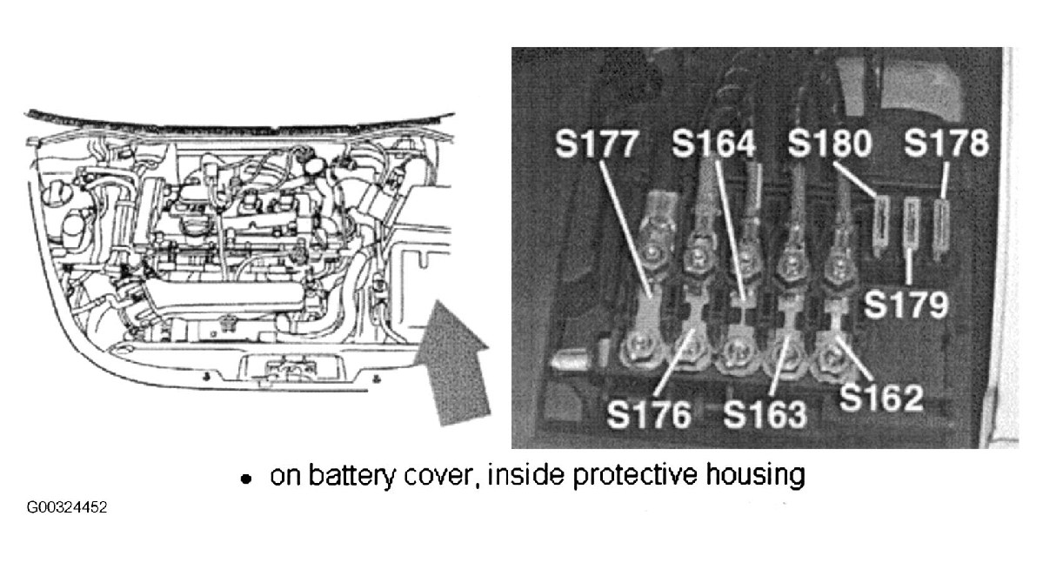



**Fig. 6: Locating Fuse Bracket/Battery Panel**

**Courtesy of VOLKSWAGEN UNITED STATES, INC.**

**FUSE IDENTIFICATION (FUSE BRACKET/BATTERY PANEL)**

|  |  |  |
| --- | --- | --- |
| **Fuse No.** | **Amp**  **Rating** |  |
| S162 | | |
| Engine Codes AVH/AZG | 50 | Secondary Air Injection Pump Relay |
| Engine Code AWV | 50 | Fuse 51 (20 A), Secondary Air Injection  Pump Relay |
| Engine Code ALH | 50 | Preheating Coolant (Low & High Heat  Output) Relay |
| S163 | | |
| Engine Codes AVH/AZG,  AWV & BDC |  |  |
|  |  |  |
|  | | |
|  | 30 | Coolant Fan Control Module |
| AWV | 30 | Third Speed Coolant Fan Control Relay |
| BDC | 40 | Secondary Air Injection Pump Relay |
| S176 | 110 | Load Reduction Relay |
| S177 | | |
| All Engine Codes | 110 | Generator |
| BDC | 150 | Generator |
| S178 | 30 | ABS Control Module |





|  |  |  |
| --- | --- | --- |
| S179 | 30 | ABS Control Module |
| S180 | 30 | Coolant Fan Control Thermal Switch |

**Fuse (Holder) Panel**

For fuse position number, amp rating and description of circuits protected, see **FUSE IDENTIFICATION (FUSE HOLDER PANEL)** table.

**NOTE: Fuses 23 through 44 may be designated in wiring diagrams with a prefix of 2.**   
**For example, fuse No. 29 may be labeled as 229. Fuse No. 43 may be labeled as**

**243.**

**FUSE IDENTIFICATION (FUSE HOLDER PANEL)**



|  |  |  |
| --- | --- | --- |
|  |  | **Circuit Protected** |
| 1 | 10 | Glove Compartment Light Switch, Glove Compartment  Light, Washer Nozzle Heater (Left & Right), Heated Mirror  Relay |
| 2 | 10 | Turn Signal Relay |
| 3 | 5 | Instrument Panel Light Dimmer Switch |
| 4 | 5 | Dual Horns, License Plate Light |
| 5 | 7.5 | Clutch Vacuum Vent Valve Switch, Power Mirror Switch,  Driver's Heated Seat Adjust Control Switch, Automatic  Day/Night Interior Mirror, Cruise Control Switch, A-C High  Pressure Sensor, Fresh Air/Recirculation Air Switch, (1)  Brake Vacuum Vent Switch, (2)Brake Pedal Switch |
| 6 | 5 | Comfort System Central Control Module, Driver's Door  Warning Indicator Light |
| 7 | 10 | Back-Up Light Switch, Park Neutral Position Relay, Selector  Lever Position Warning Light, Speedometer Vehicle Speed  Sensor, (3) Multi-Function Transmission Range Switch |
| 8 | N/A | Vacant |
| 9 | 5 | ABS Control Module, Anti-Slip Control Switch, Steering  Angle Sensor |
| 10 | | |
| All Engine  Codes |  |  |
|  | 10 | Diesel Direct Fuel Injection ECM |
| 11 | 5 | Instrument Panel, Instrument Panel Control Indicator Unit,  Shift Lock Solenoid |
| 12 | 7.5 | DLC (Terminal 16) |





|  |  |  |
| --- | --- | --- |
| 13 | 10 | High Mount Brake Light, Left Brake/Tail Light, Brake Light  Switch |
| 14 | 10 | Comfort System Central Control Module |
| 15 | 5 | Control Module W/Indicator, Transmission Control Module,  ABS Warning Indicator Light |
| 16 | 10 | Coolant Fan Control Module |
| 17 | N/A | Vacant |
| 18 | 10 | Headlight High Beam Indicator |
| 19 | 10 | Headlight (High Beam - Left) |
| 20 | 15 | Headlight (High & Low Beam - Right) |
| 21 | 15 | Daytime Running Lights Change-Over Relay, Headlight  (Low Beam - Left) |
| 22 | 5 | Control Module W/Indicator, Parking Light (Right), Front  Side Marker Light (Right), Tail Light (Right), Brake Light  (Right ) Turn Signal Light (Right Front) |
| 23 | 5 | Control Module W/Indicator, Tail Light (Left), Parking Light  (Left), Front Side Marker Light (Left), Brake Light (Left),  Turn Signal (Left), Headlight Switch |
| 24 | 20 | Wiper/Washer Intermittent Relay & Switch |
| 25 | 25 | Fresh Air Blower Switch, Fresh Air Blower Motor |
| 26 | 20 | Rear Window Defogger Switch |
| 27 | N/A | Vacant |
| 28 | 15 | Fuel Pump |
| 29 | | |
| All Engine  Codes |  |  |
|  | 10 | Diesel Direct Fuel Injection ECM |
| 30 | 20 | Power Sunroof Control Module |
| 31 | 20 | Transmission Control Module, Multi-Function Transmission  Range Switch, Brake Booster Control Module |
| 32 | | |
| All Engine  Codes |  |  |
|  | 15 | Diesel Direct Fuel Injection ECM, Modulating Piston  Displacement Sensor, PCV Heating Element |
| 33 | 20 | Wiper/Washer Intermittent Relay |
| 34 | | |
| Engine Codes  AVH/AZG &  BDC |  |  |





|  |  |  |
| --- | --- | --- |
| Engine Code AWV | 10 | Turbocharger Recirculation Valve, Wastegate Bypass Valve,  Camshaft Adjuster Valve |
|  | 10 | Wastegate Bypass Regulator Valve, EGR Vacuum Regulator  Solenoid Valve, Intake Manifold Flap Change-Over Valve,  Cold Start Injector, Glow Plug Triggering Control Module |
| 35 | 30 | (4)Luggage Compartment 12V Outlet |
| 36 | 15 | Fog Light Switch |
| 37 | 10 | Comfort System Central Control Module, Instrument Cluster,  Radio |
| 38 | 15 | Remote Fuel Door Switch & Motor, Comfort System Central  Control Module |
| 39 | 15 | Turn Signal Relay, Side Door Control Module (Driver's &  Passenger's) |
| 40 | 20 | Dual Horn Relay |
| 41 | 15 | Cigarette Lighter, Cigarette Lighter Light, 12V Socket, (5)  Luggage Compartment 12V Outlet, Lighting Controller  Illumination, Rear Window Defogger Switch Illumination |
| 42 | 25 | Radio, Amplifier, Emergency Flasher |
| 43 | | |
| All Engine  Codes |  |  |
|  | 10 | Brake Vacuum Vent Valve Solenoid, Brake Pedal Switch |
| 44 | 15 | Heated Seat Control Module (Driver's & Passenger's) |
| 67 | 30 | Convertible Top Control Module |
| 68 | 30 | Convertible Top Hydraulic Pump Relay Circuit Breaker |
| (1)On 1.8L (AWV) engines only.  (2)On 2.0L (AVH/AZG and BDC) engines only.  (3)On 2.0L Engine (BDC) only.  (4)On Convertible only.  (5)Except Convertible. | | |

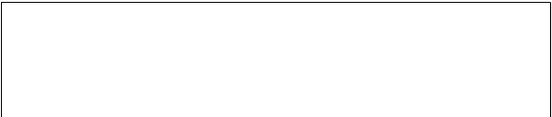

**MISCELLANEOUS FUSES**



|  |  |  |
| --- | --- | --- |
| **Fuse No.** | **Amp Rating** | **Circuit Protected** |
| S51 (1) | 20 | Brake System Vacuum Pump (Automatic Only) |
| S329 (2) | 30 | Rear Spoiler Motor |

(1)Located in left side of engine compartment, within protective housing.

(2)Only equipped on 1.8L GL.

**RELAYS**

**RELAY PANEL & THIRTEENFOLD AUXILIARY RELAY PANEL**

**NOTE: Relay panels are under driver's side of dash, behind trim panel.**

For ECM power, secondary air injection pump relays and relay for preheating coolant (high and low output)   
locations, see **Fig. 7** , **Fig. 8** or **Fig. 9** . For relay positions, see **Fig. 10** .

Thirteenfold auxiliary relay panel is located above relay panel. For relay number, position number and circuits protected, see **RELAY IDENTIFICATION (RELAY PANEL)** and **RELAY IDENTIFICATION**   
**(THIRTEENFOLD AUXILIARY RELAY PANEL)** table.

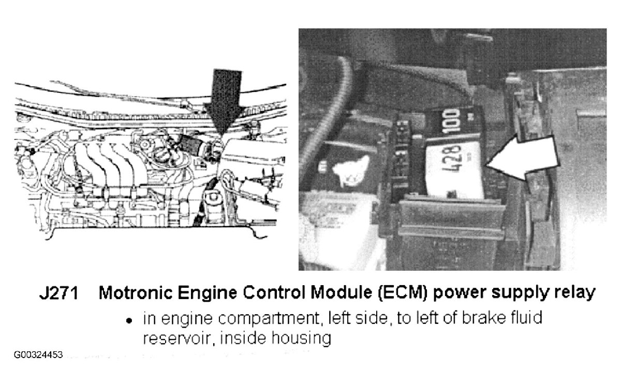















**Fig. 7: Locating ECM Power Supply Relay**

**Courtesy of VOLKSWAGEN UNITED STATES, INC.**

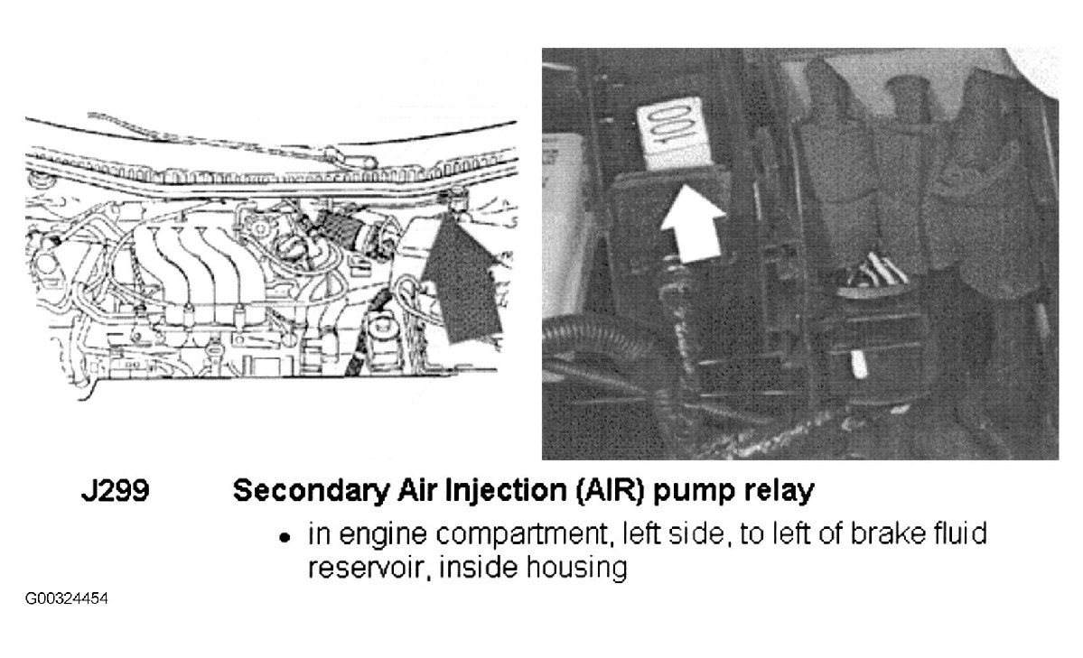

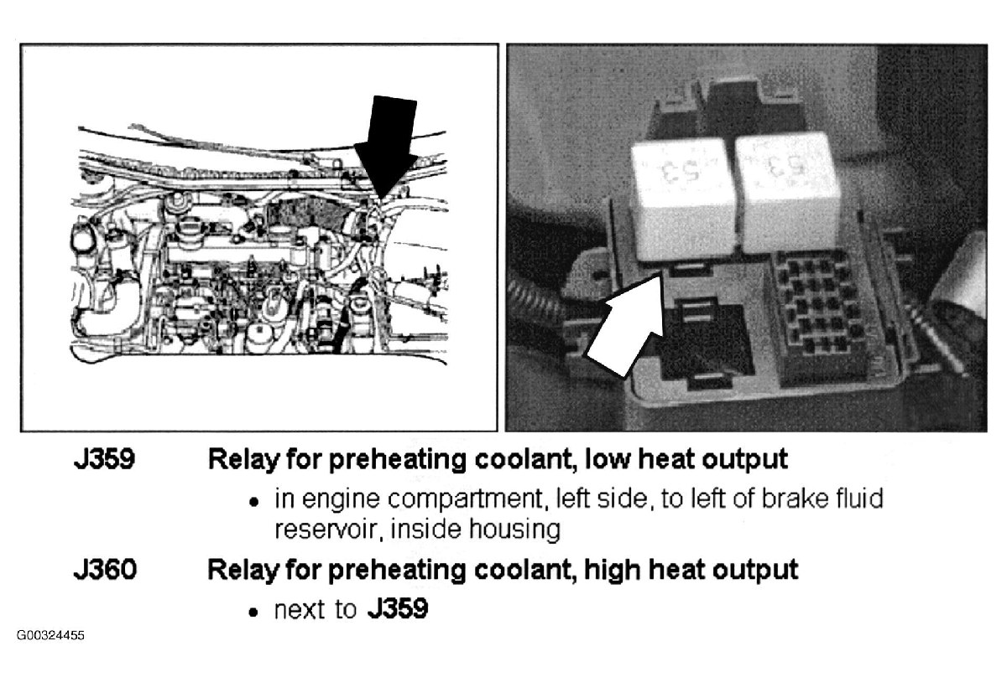



**Fig. 8: Locating Secondary Air Injection Pump Relay** **Courtesy of VOLKSWAGEN UNITED STATES, INC.**

**Fig. 9: Locating Relay For Preheating Coolant (High & Low Heat Output - 1.9L TDI ALH)** **Courtesy of VOLKSWAGEN UNITED STATES, INC.**

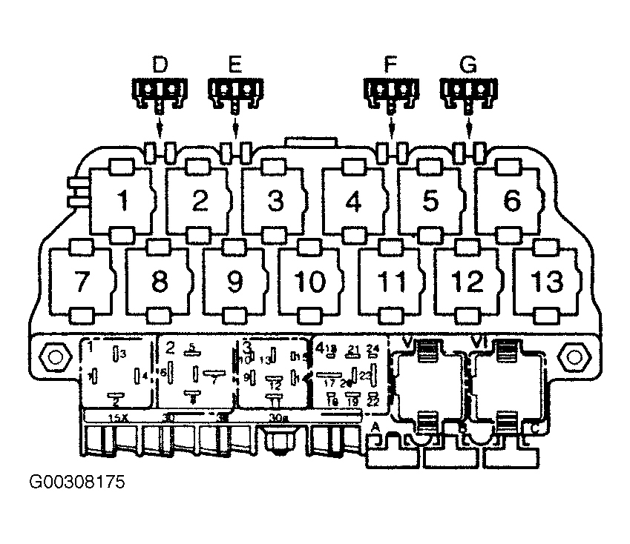

**Fig. 10: Identifying Relay Panel Components**

**Courtesy of VOLKSWAGEN UNITED STATES, INC.**

**RELAY IDENTIFICATION (RELAY PANEL)**

|  |  |  |
| --- | --- | --- |
| **Position No.** | **Relay No.** | **Circuit Protected** |
| 1 | J4 | Dual Horn |
| 2 | J59 | Load Reduction |
| 3 | N/A | Not Used |
| 4 | J17 | Fuel Pump |
| V | J31 | Wiper/Washer Intermittent |
| VI | J31 | Wiper/Washer Intermittent |

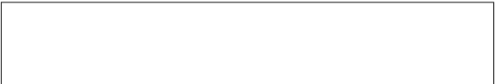

**RELAY IDENTIFICATION (THIRTEENFOLD AUXILIARY RELAY PANEL)**



|  |  |  |
| --- | --- | --- |
| **Position No.** | **Relay No.** | **Circuit Protected** |
| 1 | N/A | Not Used |
| 2 | N/A | Not Used |
| 3 | N/A | Not Used |



|  |  |  |
| --- | --- | --- |
| 4 | J434 | Lock Relay For Starter (Clutch Pedal Switch) |
| 5 | N/A | Not Used |
| 6 | N/A | Not Used |
| 7 | J89 | Daytime Running Light Change-Over |
| 8 | J99 | (1)Heated Exterior Mirror |
| 9 | N/A | Not Used |
| 10 | | |
| J52 | | (2)Glow Plug |
| J135 | | (3)Third Speed Coolant Fan Control |
| 11 | J226 | Park/Neutral Position |
| 12 | J317 | (2)Power Supply (Terminal 30, B+) |
| 13 | N/A | Not Used |
| (1)On models equipped with manual windows.  (2)Applies to vehicles equipped with 1.9L (ALH) only.  (3)On 1.8L (AWV) only. | | |

**NOTE: Fuse panel is located above thirteenfold auxiliary relay panel. For positions on**   
**thirteenfold auxiliary relay panel, see Fig. 10 .**

**FUSE IDENTIFICATION (THIRTEENFOLD AUXILIARY RELAY PANEL)**

|  |  |  |  |
| --- | --- | --- | --- |
| **Position No. (1)** | **Fuse No.** | **Amp Rating** | **Circuit Protected** |
| B (2) | S283 | 15 | Brake Vacuum Pump |
| E | S43 | 30 | Power Window Circuit Breaker |
| F | S111 | 15 | Alarm System & Anti-Theft |
| G | S144 | 15 | Central Locking/Anti-Theft Warning System |
| (1)Manufacturer does not specify position of fuse. Available position is "A", "C" and  "D".  (2)On convertible models only. | | | |